GIATA Integration Requirements Overview

|  |  |  |  |
| --- | --- | --- | --- |
| Version | Description | Who | When |
| 1.0 | First version – working document for GIATA Tourplan integration | Craig | 18/10/2017 |
| 1.1 | Updated with estimated development effort | Craig | 28/11/2017 |
| 1.2 | Updated with agreed initial strategy to load content into clients TP system | Craig | 24/07/2018 |
| 1.3 | Change from using productConnect to using webServices | Craig | 06/08/2018 |
| 1.4 | Add screen layouts | Craig | 17/08/2018 |

# Background

Traditionally our clients have manually loaded hotel (property) content into their Tourplan system, including text and images content. This content is output on itinerary documentation sent to their agents/clients, and is also be used on online booking sites such as webConnect/hostConnect.

This content loading is a large and cumbersome task for clients to maintain, and they would like to be able to download the hotel descriptions and images into their Tourplan system, to avoid them manually having to find and enter this content.

This is where GIATA comes in. GIATA collates and provides hotel content (descriptions, images, addresses, amenities, geocodes etc) for 620,000 hotels/resorts worldwide [www.giata.com](http://www.giata.com)

We have been approached by a number of clients over last 2-3 years, most recently by APTC and ExoTravel, regarding integrating with GIATA to use their hotel content.

# Integration Strategy

## Phase 1:

Write a new ‘Mapping’ application which reads GIATA propertyIDs (from a downloaded CSV or XML structured file), matches the GIATA property to the Tourplan property (tourism product supplier), and records the GIATA property ID against the supplier

The above application will only be run by user controlled initiation.

## Phase 2:

Write a new ‘Content’ application that extracts the primary GIATA property description via the existing GIATA API and uploads it into each client’s Tourplan system via Tourplan web Services

The above application will must be able to be run on a scheduled (eg nightly) basis and also on-demand (via user controlled initiation)

## Phase 3:

Extend the ‘Content’ application to also upload other property information from the GIATA response including amenities, links to images and additional descriptive content

# Functional Requirements

## Phase 1: Mapping Tool

GIATA properties each have a unique propertyID. These propertyIDs will need recorded in the clients Tourplan system against the associated supplier (property), so that we can then use the GIATA API to download the content for those properties.

A mapping tool is required to:

1. Read a list (CSV or XML) from GIATA consisting of property name, address and ID
2. Read Tourplan suppliers
3. Match the Giata property to the Tourplan supplier by closest match of property name and city)
4. Where a found match meets the minimum criteria, using Tourplan webServices record the GIATA propertyID against the Tourplan supplier (in a supplier note)

## Phase 2: GIATA Interface – Descriptions Only

A ‘GIATA Interface’ is required that can:

* Read the list of GIATA IDs from Tourplan using Tourplan webServices.
* Send these to GIATA in the required format
* Receive and parse the response from GIATA for updating Tourplan. At this stage we are only interested in uploading the property description into a single Tourplan supplier note.
* Send the request to Tourplan webServices to update the content into Tourplan

## Phase 3: GIATA Interface – Additional Content

Extend the above ‘GIATA Interface’ to:

* Send to appropriate queries (using extra content request flags) to GIATA
* Receive and parse the additional content including amenities, images and extra descriptions response from GIATA for updating Tourplan.
* Send the request to Tourplan web services to update the content into Tourplan

### GIATA APIS

GIATA has 2 APIs

* Multicodes – which can return lists of properties, addresses and GIATA IDs
* MHG – which returns the actual hotel content

At this point we will only be using the MHG API <http://www.ghgml.giatamedia.com/webservice/specs/>

User: multicodes|tourplan.com

Password is: HqsGvDbt

The APIs are not live APIs. Test access allows you to retrieve 1,000 random GIATA IDs.

Further information is available via the FAQs

<http://www.giata.com/fileadmin/Redakteure/Bilder_PDF_Videos/Online_Produkte/Multilingual_Hotel_Guide/MHG_Integration_FAQs.pdf>

For further technical assistance during integration we can contact GIATA technical support Pramod via [integration.giata@gmail.com](mailto:integration.giata@gmail.com).

# Screen Layouts

## Phase 1: Mapping Tool

### Search Screen

# GIATA Mapping



GIATA Country

Uastralia

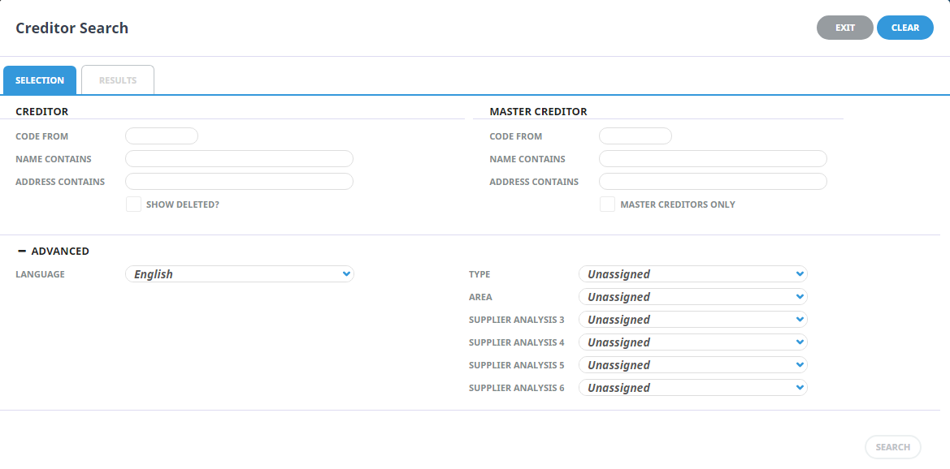

Tourplan Supplier Search

### Results & Mapping Screen

# GIATA Mapping

|  |  |  |  |  |
| --- | --- | --- | --- | --- |
| TOURPLAN SUPPLIER | | |  | GIATA SUPPLIER |
| NAME | **ADDRESS1** | **ADDRESS2** | **MATCH** | **NAME & CITY** |
| Aarons Hotel | 12 Main St | Sydney | ✓ | Aarons Hotel  Sydney |
| Hilton Hotel Darling Harbour | 1 Darling Harbour | Sydney | ✓ | Hilton Darling Harbour, Sydney |
| Novotel Darling Harbour | 15 Wharf St | Sydney | ✓ | Novotel Darling Harbour, Sydney |
| Sheraton Manly | 14 Main St | Sydney | 🗶 | NO MATCH FOUND |
| Westin Apartments | 12 Queen St, The Rocks | Sydney | ✓ | Westin Apartments The Rocks,  Sydney |



**EDIT**

**EDIT**

**EDIT**

**EDIT**

**EDIT**

Clicking the Edit button on the screen above will display the following modal for the user to select the correct GIATA supplier

### GIATA Hotel Selection Screen

# GIATA Hotel Selection

|  |  |  |  |
| --- | --- | --- | --- |
| HOTEL NAME | CITY | COUNTRY |  |
| Aarons Hotel | 12 Main St | Sydney |  |
| Hilton Hotel Darling Harbour | 1 Darling Harbour | Sydney |  |
| Novotel Darling Harbour | 15 Wharf St | Sydney |  |
| Sheraton Manly | 14 Main St | Sydney |  |
| Westin Apartments | 12 Queen St, The Rocks | Sydney |  |

**SELECT**

**SELECT**

**SELECT**

**SELECT**

**SELECT**

## Phase 2: GIATA Interface – Descriptions Only

The updating of descriptions from GIATA into Tourplan must be able to be run:

1. On an automated scheduled basis with no user input. This should use the GIATA Last_Changed capability to only get and update changed/new descriptions from GIATA
2. Via user controlled initiation. See screen below for user controlled initiation



# GIATA Content Updating



**UPDATE CONTENT FROM GIATA**